# 参考代码

## 参看

Name

Length:默认255，date类型不写

Nullable:空，默认为空

Unique：唯一，默认不

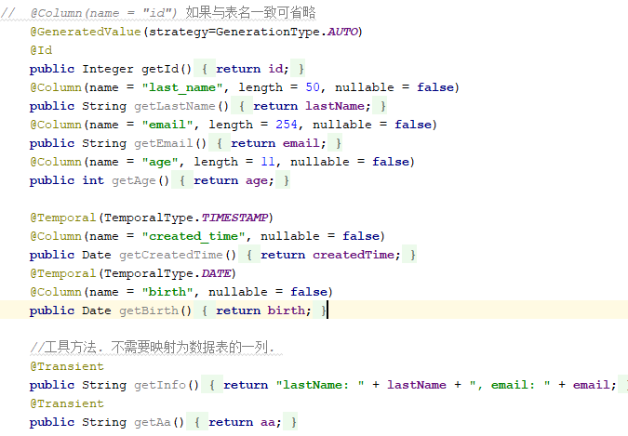

## Demo

@Table(name=**"CUTOMERS"**)  
@Entity  
**public class** Customer {  
   
 **private** Integer **id**;  
 **private** String **lastName**;  
  
 **private** String **email**;  
 **private int age**;  
   
 **private** Date **createdTime**;  
 **private** Date **birth**;  
   
 **private** String **aa**;  
   
*// @Column(name = "id") 如果与表名一致可省略* @GeneratedValue(strategy=GenerationType.***AUTO***)  
 @Id  
 **public** Integer getId() {  
 **return id**;  
 }  
 @Column(name = **"last_name"**, length = 50, nullable = **false**)  
 **public** String getLastName() {  
 **return lastName**;  
 }  
 @Column(name = **"email"**, length = 254, nullable = **false**)  
 **public** String getEmail() {  
 **return email**;  
 }  
 @Column(name = **"age"**, length = 11, nullable = **false**)  
 **public int** getAge() {  
 **return age**;  
 }  
  
 @Temporal(TemporalType.***TIMESTAMP***)  
 @Column(name = **"created_time"**, nullable = **false**)  
 **public** Date getCreatedTime() {  
 **return createdTime**;  
 }  
 @Temporal(TemporalType.***DATE***)  
 @Column(name = **"birth"**, nullable = **false**)  
 **public** Date getBirth() {  
 **return birth**;  
 }  
  
 *//工具方法. 不需要映射为数据表的一列.* @Transient  
 **public** String getInfo(){  
 **return "lastName: "** + **lastName** + **", email: "** + **email**;  
 }  
 @Transient  
 **public** String getAa() {  
 **return aa**;  
 }  
  
  
  
  
 **public void** setAa(String aa) {  
 **this**.**aa** = aa;  
 }  
 **public void** setId(Integer id) {  
 **this**.**id** = id;  
 }  
 **public void** setLastName(String lastName) {  
 **this**.**lastName** = lastName;  
 }  
 **public void** setEmail(String email) {  
 **this**.**email** = email;  
 }  
 **public void** setAge(**int** age) {  
 **this**.**age** = age;  
 }  
 **public void** setCreatedTime(Date createdTime) {  
 **this**.**createdTime** = createdTime;  
 }  
 **public void** setBirth(Date birth) {  
 **this**.**birth** = birth;  
 }  
 @Override  
 **public** String toString() {  
 **return "Customer [id="** + **id** + **", lastName="** + **lastName** + **", email="** + **email** + **", age="** + **age** + **", createdTime="** + **createdTime** + **", birth="** + **birth** + **"]"**;  
 }  
  
  
}